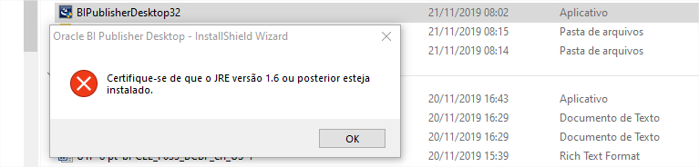

<https://www.oracle.com/middleware/technologies/bi-publisher/downloads.html>

**Java desktop atual**

